**Deployment yaml to test nginx standard deployment on AKS**

apiVersion: apps/v1

kind: Deployment

metadata:

name: web

spec:

selector:

matchLabels:

app: nginx

replicas: 2 # tells deployment to run 2 pods matching the template

template:

metadata:

labels:

app: nginx

spec:

containers:

- name: nginx

image: nginx:1.14.2

ports:

- containerPort: 80

---

apiVersion: v1

kind: Service

metadata:

name: web

spec:

type: LoadBalancer

ports:

- port: 80

selector:

app: web

**Deployment yaml for go web server container ‘beta_1’**

apiVersion: apps/v1

kind: Deployment

metadata:

name: web

spec:

selector:

matchLabels:

app: beta

replicas: 3

template:

metadata:

labels:

app: beta

spec:

containers:

- name: beta

image: russellemergentai/beta_1

ports:

- containerPort: 8080

---

apiVersion: v1

kind: Service

metadata:

name: web

spec:

type: LoadBalancer

ports:

- port: 8080

selector:

app: beta

**Debugging a pod/container on AKS**

CHECK LOGS for the pod

============

russell@Azure:~$ kubectl logs web-65f9f75fdf-nw4ss

Hello, starting...

____ __

/ __/___/ / ___

/ _// __/ _ \/ _ \

/___/\__/_//_/\___/ v4.7.2

High performance, minimalist Go web framework

https://echo.labstack.com

____________________________________O/_______

O\

⇨ http server started on [::]:8080

**SUCCESSFUL**

CONNECT FROM ADJACENT POD

=============================

kubectl run -it --rm aks-ssh --image=debian

apt-get update -y && apt-get install dnsutils -y && apt-get install curl -y

root@aks-ssh:/# curl http://10.244.0.13:8080/users/bob

Hello bobroot@aks-ssh:root@aks-ssh:/# curl http://10.244.0.13:8080/

server running

**SUCCESSFUL**

SO IS POD ACCESSIBLE FROM SERVICE

=================================

russell@Azure:~$ kubectl describe svc web

Name: web

Namespace: default

Labels: <none>

Annotations: <none>

Selector: app=web

Type: LoadBalancer

IP Family Policy: SingleStack

IP Families: IPv4

IP: 10.0.106.39

IPs: 10.0.106.39

LoadBalancer Ingress: 20.26.32.20

Port: <unset> 8080/TCP << OK

TargetPort: 8080/TCP << OK

NodePort: <unset> 30475/TCP

Endpoints: <none> <<<<<<<< this should be the pod IP. where is it!!

Session Affinity: None

POD app is beta and it was not set correctly (it was web) in the deployment.yaml

====================================================================

russell@Azure:~$ kubectl get pods --show-labels

NAME READY STATUS RESTARTS AGE LABELS

web-65f9f75fdf-nw4ss 1/1 Running 0 45m app=beta,pod-template-hash=65f9f75fdf

russell@Azure:~$ kubectl describe svc web

Name: web

Namespace: default

Labels: <none>

Annotations: <none>

Selector: app=beta

Type: LoadBalancer

IP Family Policy: SingleStack

IP Families: IPv4

IP: 10.0.106.39

IPs: 10.0.106.39

LoadBalancer Ingress: 20.26.32.20

Port: <unset> 8080/TCP

TargetPort: 8080/TCP

NodePort: <unset> 30475/TCP

Endpoints: 10.244.0.13:8080 <<<< now this exists

Session Affinity: None

External Traffic Policy: Cluster

ACCESS LOADBALANCER

==================

C:\Users\USER>curl -Iv http://20.26.32.20:30475/users/bob

* Trying 20.26.32.20:30475...

* Connected to 20.26.32.20 (20.26.32.20) port 30475 (#0)

> HEAD /users/bob HTTP/1.1

> Host: 20.26.32.20:30475

> User-Agent: curl/7.79.1

> Accept: */*

>

* Recv failure: Connection was reset

* Closing connection 0

curl: (56) Recv failure: Connection was reset

hang on ----it responded on http://20.26.32.20:8080/users/bob

and curl http://20.26.32.20:8080/users/bob

C:\Users\USER>curl http://20.26.32.20:8080/users/bob

Hello bob

***8080***the endpoint is wrong!

**SETTING UP AKS FROM THE PORTAL**

Just a standard deployment, with no modifications:

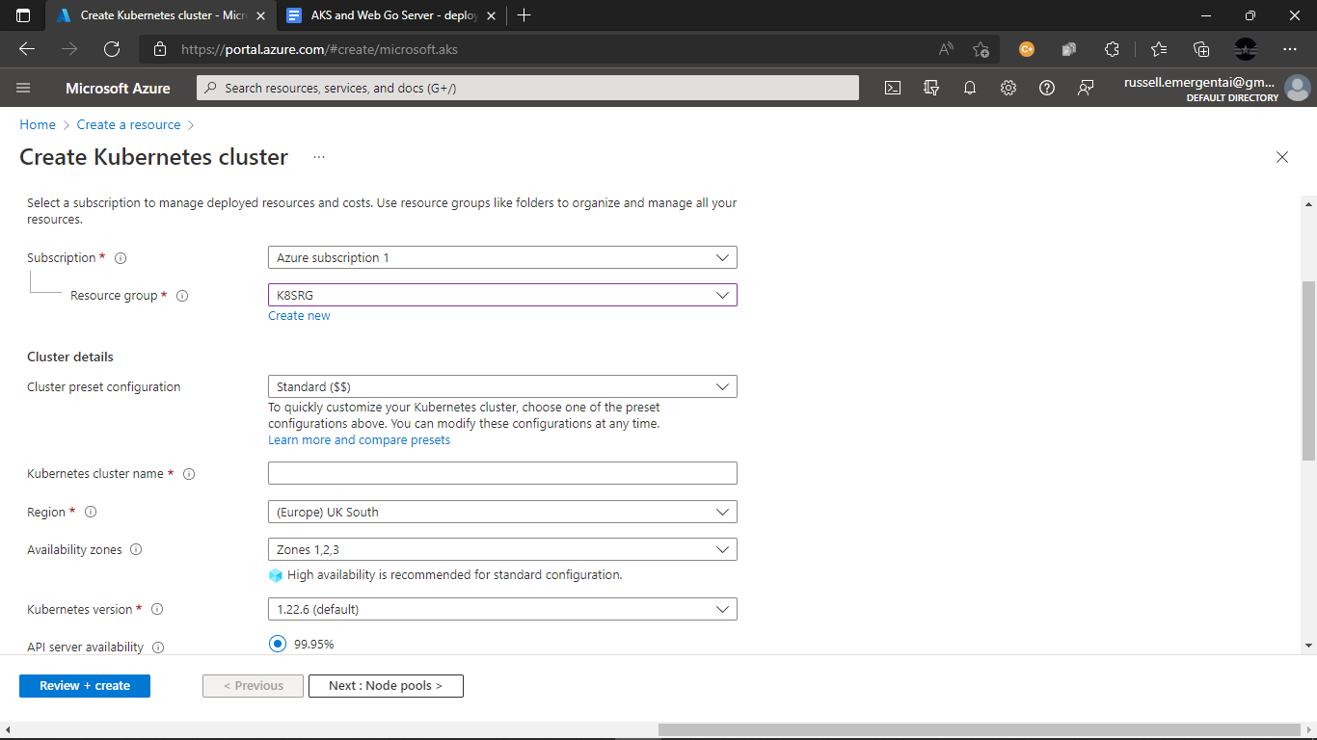

To run the actual deployment, start the cloud shell (top right icon) and use:

**vi deployment.yaml**

{

….paste in the yaml

}

Then **[esc], :x, [return]**

Then run the following:....

// az aks get-credentials --resource-group K8SRG --name aksbetatest

// kubectl apply -f deploy.yml

// curl http://20.108.239.131:30475/users/bob

Note that the IP here is the **external IP of the K8S server**:

Ie *kubectl describe svc web*

LoadBalancer Ingress: 20.26.32.20

This can also be found from *kubectl get services*

And then the web server can be hit in its pod with:

C:\Users\USER>curl http://20.26.32.20:8080/users/bob

Hello bob